

*TRAN DUC ANH DANG  
ERTESAM NASER ZARIF  
LUAN NGUYEN  
NATHAN KO*

*ASSIGNMENT 1*

*Restaurant Information System*

# Abstract

This document outlines the proposal for a comprehensive Restaurant Information System designed to revolutionize the daily operations of The Relaxing Koala, a café/restaurant located on Glenferrie Road. With the recent expansion of its premises, enabling the accommodation of up to 150 customers from a previous capacity of 50, The Relaxing Koala faces the challenge of scaling its operations efficiently. The proposed system aims to automate and streamline the restaurant's operations, enhancing the customer experience while ensuring operational efficiency. Key functionalities include digital reservation management, order processing, real-time kitchen integration, payment processing, inventory management, and insightful analytics on customer preferences and operational performance. By adopting a phased implementation strategy, starting with essential modules followed by advanced features, The Relaxing Koala intends to optimize its workflow, improve service delivery, and foster business growth in a competitive market. This document provides a detailed analysis of the restaurant's current operational challenges, system goals, functional requirements, and potential solutions, laying the foundation for a technology driven transformation aimed at enhancing customer satisfaction and operational excellence.

Table of Contents

Abstract 1

Introduction 4

Project Overview 4

Domain Vocabulary 4

Goals 4

Assumptions 5

Scope 5

Problem Domain 5

Pain Points 5

Domain Entities 6

Actors 6

Tasks 7

Functional Requirements and Task Descriptions 8

Reservation Management 8

Walk-in Management 9

Order Processing 10

Payment Process 11

Inventory Management 12

Table Turnover Management 13

Customer Feedback Collection 14

Staff Scheduling 15

Maintenance and Upkeep 16

System Maintenance and Update 17

Supplier coordinator 18

Workflow 19

Reservation Management 19

Order Processing 21

Payment Processing 22

Inventory Management 22

Table Turnover Management 24

Customer Feedback Collection 25

Staff Scheduling 26

Maintenance and Upkeep 27

System Maintenance and Update 28

Supplier Coordination 29

Data Model 30

Domain Model 30

Entity descriptions 30

Quality Attributes of System 31

Reliability 31

Security 31

Scalability 31

Portability 32

Other Requirements 32

Menu Management 32

Accessibility Support 32

Validation of Requirements 32

Objectives of Validation of Requirements 32

Validation Process Overview 32

Possible Solutions 33

Standard staff-customer hybrid approach 33

Customer self-service 34

Cloud-based solution 34

# Introduction

The Relaxing Koala, a popular café/restaurant located on Glenferrie Road, is during an exciting expansion. Having recently acquired an adjoining property, the establishment is set to triple its capacity from hosting approximately 50 customers to 150. This expansion, while promising, brings to light the limitations of the current low-tech, manual operation methods, particularly in order taking, kitchen communication, and financial transactions. Recognizing the need to scale operations efficiently to match the expanded capacity, the owners are now considering the implementation of an information system designed to streamline daily operations and enhance the customer experience.

# Project Overview

The Relaxing Koala aims to introduce a comprehensive information system that supports and improves upon the current manual processes inherent to the restaurant's operations. This new system is envisioned to not only handle reservations and orders but also to integrate seamlessly with the kitchen, finance, and customer service functions. By leveraging technology, the Relaxing Koala seeks to optimize its workflow, enhance customer satisfaction, and drive growth in a competitive market.

## Domain Vocabulary

* Reservation: Booking a table at the restaurant in advance.
* Order: Customer selections from menu for dine-in or takeaway.
* Invoice: A bill for services, rendered, detailing orders and associated costs.
* Receipt: A documentation provided to customers as proof of payment.
* Menu Item: Individual dishes or beverages offered by the restaurant.
* Takeaway: Food ordered to be consumed outside the restaurant premises.
* Delivery: The process of transporting ordered food to the customer's location.

## Goals

* Operational Streamlining: Automate and enhance the efficiency of restaurant operations, accommodating both reserved and walk-in customers seamlessly.
* Enhanced Customer Experience: Improve the overall dining, ordering, and payment experience for all guests, ensuring swift service whether they've booked in advance or decided to visit on a whim.
* Accuracy and Efficiency in Transactions: Provide precise and fast handling of orders and payments, minimizing errors and wait times for both reservation and walk-in guests.
* Insightful Data Analysis: Collect and analyse data on dining preferences and patterns, including the choices of walk-in customers, to better tailor the restaurant's offerings.
* Expanding Online Interaction: Offer an intuitive online platform for menu exploration, reservations, and ordering, while also accommodating the needs of guests who prefer to dine without prior booking.

## Assumptions

* Adaptability: Both staff and customers, regardless of their reservation status, will adapt to and embrace the use of the new information system for an improved dining experience.
* Reliable Connectivity: Constant and reliable internet access will be available to support the system's functionalities, including online reservations and walk-in management.
* Effective Training: Staff will be adequately trained to utilize the system efficiently, ensuring smooth service for both reserved and walk-in customers.
* Customer Engagement: Guests will appreciate the enhanced service options provided by the system, including the ease of making reservations and the streamlined process for walk-ins.

## 

## Scope

The system will encompass a comprehensive set of functionalities designed to optimize the restaurant's operations and customer service:

* Reservation Management: Digital booking for customers who prefer planning ahead, with real-time table availability updates.
* Walk-in Management: Efficient handling of walk-in customers, including wait times estimation and quick table allocation.
* Order Processing: A unified system for taking and processing orders from both reserved and walk-in guests, ensuring accuracy and speed.
* Payment Facilitation: Quick and secure payment processing, catering to the diverse needs of all customers.
* Analytics and Reporting: Detailed analytics on customer preferences, popular dishes, and operational efficiency, with insights into both reservation and walk-in trends.
* Online Services: Up-to-date online menus and the option for remote ordering, serving both those who plan and spontaneous visitors.

# Problem Domain

## Pain Points

* Service Efficiency: Challenges in efficiently managing both reservations and walk-in customers, especially during peak times.
* Order and Payment Processing: Inconsistencies and delays in taking orders and processing payments, affecting customer satisfaction.
* Customer Data Insights: A lack of comprehensive data analysis that includes the preferences and feedback of both reserved and walk-in guests.
* Table Turnover: Difficulty in optimizing table turnover rates to accommodate the maximum number of guests, including those without reservations.

## 

## Domain Entities

* Customer: Individuals or groups that visit the restaurant, including those with reservations and walk-ins.
* Order: The selection of menu items requested by customers, which can vary between dine-in, takeaway, and delivery options.
* Menu Item: Individual dishes, drinks, or set meals available for customers to order.
* Table: Physical spaces within the restaurant designated for customer dining. Includes details such as capacity and location within the restaurant.
* Reservation: A record of a table booked by a customer for a specific date and time.
* Payment Transaction: Records of financial transactions made by customers for their orders, including method of payment and amount.
* Feedback: Customer reviews and ratings regarding their dining experience, menu items, and service quality.
* Employee: Staff members of the restaurant, including servers, hosts, and kitchen staff, with details on roles and schedules.

## 

## Actors

* Server: Staff members who take orders, serve food, and manage customer queries and payments within the restaurant.
* Host/Hostess: Employees responsible for greeting customers, managing reservations and walk-in waiting lists, and seating guests.
* Chef/Kitchen Staff: Individuals working in the kitchen, responsible for preparing meals according to orders, managing inventory, and maintaining food quality.
* Cashier: Employees who handle the final billing and payment transactions, ensuring accuracy in charges and processing payments.
* Manager: Senior staff overseeing the operation of the restaurant, including employee management, financial oversight, and customer service quality.
* Customer (Reserved): Customers who have made reservations in advance for their dining experience.
* Customer (Walk-in): Customers who visit the restaurant without a prior reservation.
* Supplier: Entities or individuals who provide the restaurant with ingredients, kitchen supplies, and other necessities.
* Maintenance Personnel: Staff or contracted individuals responsible for the upkeep and repair of restaurant facilities and equipment.
* IT Support: Individuals or teams responsible for the maintenance, troubleshooting, and updating of the restaurant's information system.

## 

## Tasks

* Reservation Management:
  + Actor: Host/Hostess, Customer (Reserved), IT Support
  + Description: Manage and record reservations made online or by phone. Includes allocation of tables and managing cancellations or modifications.
* Walk-in Management:
  + Actor: Host/Hostess, Customer (Walk-in)
  + Description: Handle walk-in customers efficiently, including estimating wait times, managing a waiting list, and seating customers as tables become available.
* Order Processing:
  + Actor: Server, Chef/Kitchen Staff, Customer
  + Description: Take orders from customers, relay them to the kitchen, and ensure accurate and timely preparation and delivery of food.
* Payment Processing:
  + Actor: Server, Cashier, Customer
  + Description: Generate accurate bills based on customer orders, process payments, and handle payment discrepancies or refunds.
* Inventory Management:
  + Actor: Chef/Kitchen Staff, Manager, Supplier
  + Description: Monitor and manage inventory levels, place orders for supplies as needed, and check deliveries for accuracy.
* Table Turnover Management:
  + Actor: Server, Host/Hostess, Maintenance Personnel
  + Description: Prepare tables for new customers following departures, ensuring cleanliness and proper setup.
* Customer Feedback Collection:
  + Actor: Server, Manager, Customer
  + Description: Collect and review feedback from customers regarding their dining experience, menu satisfaction, and service quality for continuous improvement.
* Staff Scheduling:
  + Actor: Manager, Employee
  + Description: Schedule work shifts for all restaurant staff, ensuring adequate coverage during peak times and managing time-off requests.
* Maintenance and Upkeep:
  + Actor: Maintenance Personnel, Manager
  + Description: Regular maintenance checks and repairs of restaurant facilities and equipment to ensure operational efficiency and safety.
* System Maintenance and Update:
  + Actor: IT Support, Manager
  + Description: Perform regular maintenance on the restaurant's information system, update software as needed, and troubleshoot technical issues to ensure seamless operation.
* Supplier Coordination:
  + Actor: Manager, Chef/Kitchen Staff, Supplier
  + Description: Coordinate with suppliers for regular deliveries and manage relationships to ensure the quality and timely provision of goods.

# Functional Requirements and Task Descriptions

## Reservation Management

|  |  |
| --- | --- |
| Task: Reservation Management | |
| Purposes: | * Manage reservations: record, allocate tables, handle cancellations/modifications. |
| Trigger/Precondition: | * A customer reserves a table online or by phone. |
| Frequency: | * Variable, depending on restaurant popularity and seasonality. |
| Critical: | * Efficiently manage reservations and table allocations. |
| Work Area: | * Reservation Desk |
| SubTask: | Example Solution |
| Record Reservation Details | * Provide interface for recording reservation details: customer name, party size, date, time. * Ensure accuracy. |
| Allocate Tables | * Automatically assign tables based on party size and preferences. * Allow manual assignment as needed. |
| Variant |  |
| Integration with POS System | * The reservation system syncs with POS for seamless table availability management. |
| Customer Notification System | * The system auto-confirms reservations with details and instructions to customers. |

## Walk-in Management

|  |  |
| --- | --- |
| Task: Walk-in Management | |
| Purposes: | * Efficiently manage walk-ins by estimating wait times and seating promptly. |
| Trigger/Precondition: | * Walk-in customers arrive at the restaurant |
| Frequency: | * Variable, depending on restaurant traffic |
| Critical: | * Promptly estimate wait times and seat walk-ins. |
| Work Area: | * Entrance/Host Stand |
| SubTask: | Example Solution |
| Manage Waiting List | * The system keeps a digital waiting list, noting customer details * Alerts when tables are available, assigning them accordingly. |
| Allocate Customer seat | * Guides efficient seating, considering party sizes, table availability, and preferences. * Tracks turnover to minimize wait times. |
| Variant |  |
| Priority Seating for Loyalty Program Members | * Prioritizes seating for members of the restaurant's loyalty program(enhance loyalty) |
| Mobile Waitlist Management | * Offers a mobile app for customers to join the waitlist remotely and receive notifications when their table is ready |
| Analytics for Waitlist Optimization | * Analyzes waitlist data to identify patterns and optimize seating strategies |

## Order Processing

|  |  |
| --- | --- |
| Task: Order Processing | |
| Purposes: | * Take and relay orders swiftly, ensuring accurate food preparation and timely delivery. |
| Trigger/Precondition: | * Customers place orders with the server. |
| Frequency: | * Continuous during restaurant operating hours |
| Critical: | * Efficient order taking for timely service. |
| Work Area: | * Dining Area, Kitchen |
| SubTask: | Example Solution |
| Take Customer Orders | * Provide interface for accurate input. * Allow special requests. |
| Relay Orders to Kitchen | * Transmit orders, prioritize, ensure clarity. |
| Monitor Order Status | * Track kitchen progress. * Provide real-time updates. * Alert when ready. |
| Variant |  |
| Order Customization Options | * Allow customer order customization. * Accommodate dietary restrictions and preferences. |
| Integration with Inventory | * Track ingredient availability. * Prevent orders for out-of-stock items. |
| Kitchen Display System | * Provide digital display for chefs. * View incoming orders and manage preparation efficiently. |

## Payment Process

|  |  |
| --- | --- |
| Task: Payment Process | |
| Purposes: | * Generate accurate bills based on orders, process payments, and handle discrepancies/refunds. |
| Trigger/Precondition: | * Customers request the bill after finishing their meal |
| Frequency: | * Continuous during restaurant operating hours |
| Critical: | * Ensure accurate billing and payment processing. |
| Work Area: | * Dining Area, Cashier Station |
| SubTask: | Example Solution |
| Generate Bills | * Automatically generate bills with itemized lists and accurate pricing. * Calculate taxes, discounts, and charges. |
| Process Payments | * Support various payment methods. * Securely process payments and issue receipts. |
| Handle Discrepancies | * Address billing discrepancies promptly. * Facilitate refunds or adjustments for customer satisfaction. |
| Variant |  |
| Split Bill Functionality | * Provides an option to split bills among multiple methods or individuals. |
| Integration with Loyalty Program | * Integrate with the restaurant's loyalty program for discounts or reward redemption. |
| Contactless Payment Options | * Support NFC or QR code payments for enhanced convenience and hygiene. |

## Inventory Management

|  |  |
| --- | --- |
| Task: Inventory Management | |
| Purposes: | * Monitor inventory, place orders, and verify deliveries for accuracy. |
| Trigger/Precondition: | * Inventory reach the threshold level |
| Frequency: | * Regularly, based on usage patterns and inventory turnover |
| Critical: | * Ensure accurate inventory management and ordering. |
| Work Area: | * Kitchen, Storage |
| SubTask: | Example Solution |
| Monitor Inventory Levels | * Track inventory in real-time, including ingredients, supplies, and equipment. * Alert staff of low levels. |
| Place Orders | * Automatically generate purchase orders when levels drop. * Allow staff review and approval before sending. |
| Check Deliveries | * Verify accuracy and quality of incoming deliveries. Record received items and update inventory accordingly. |
| Variant |  |
| Ingredient Tracking for Recipes | * Integrate with recipe management software to track ingredient usage. * Adjust inventory levels accordingly. |
| Forecasting and Demand Planning | * Analyze historical data for forecasting future demand. * Optimize inventory levels and ordering quantities. |
| Supplier Performance Monitoring | * Track supplier performance metrics. * Evaluate delivery timeliness and product quality for informed purchasing decisions. |

## Table Turnover Management

|  |  |
| --- | --- |
| Task: Table Turnover Management | |
| Purposes: | * Prepare tables for new customers post-departure, ensuring cleanliness and proper setup. |
| Trigger/Precondition: | * Customers leave their tables after dining |
| Frequency: | * Continuous during restaurant operating hours |
| Critical: | * Promptly clear and clean tables for new customers. |
| Work Area: | * Dining Area |
| SubTask: | Example Solution |
| Clear Tables | * Alert staff when customers leave tables. * Efficiently remove used items from the table. |
| Clean and Reset Tables | * Guide staff in thorough cleaning and resetting. * Ensure proper sanitation and setup according to standards. |
| Manage Waiting Area | * Track cleaned table availability. * Communicate availability to host/hostess for efficient seating of waiting customers |
| Variant |  |
| Automated Table Tracking System | * Use sensors or RFID technology for real-time table status tracking. * Prioritize cleaning efforts accordingly. |
| Integration with Reservation System | * Sync with reservation system to promptly allocate cleaned tables to reserved parties upon arrival. |
| Table Configuration Customization | * Allow staff to customize table configurations based on party size and seating preferences. |

## Customer Feedback Collection

|  |  |
| --- | --- |
| Task:Customer Feedback Collection | |
| Purposes: | * Collect and review customer feedback for continuous improvement. |
| Trigger/Precondition: | * Customers complete their dining experience. |
| Frequency: | * Continuous, but may vary based on customer traffic |
| Critical: | * Gather and analyze customer feedback consistently. |
| Work Area: | * Dining Area, Manager's Office |
| SubTask: | Example Solution |
| Collect Feedback | * Prompt servers for feedback. * Provide structured format for various aspects. |
| Review Feedback | * Aggregate and categorize feedback for review by managers. |
| Act on Feedback | * Enable managers to take corrective actions based on feedback. * Address specific issues. |
| Variant |  |
| Online Feedback Platform Integration | * Integrate with online review platforms to gather feedback from customers. |
| Feedback Incentive Program | * Implement an incentive program for feedback with discounts, coupons, or loyalty points. |
| Real-time Feedback Kiosks | * Install strategically placed kiosks in the restaurant for real-time feedback. |

## Staff Scheduling

|  |  |
| --- | --- |
| Task: Staff Scheduling | |
| Purposes: | * Schedule staff shifts for peak coverage and manage time-off requests. |
| Trigger/Precondition: | * Manager approves work schedules |
| Frequency: | * Weekly or fortnightly, with adjustments for peak times and employee requests. |
| Critical: | * Optimize staff scheduling for peak coverage. |
| Work Area: | * Manager's Office |
| SubTask: | Example Solution |
| Shift Assignment | * Assign shifts based on availability, skills, and seniority. * Optimize scheduling efficiency. |
| Time-off Requests | * Allow employees to request time-off. * Manage requests and ensure adequate coverage. |
| Shift Adjustments | * Enable managers to make real-time adjustments to schedules. * Optimize staffing levels as needed. |
| Variant |  |
| Automated Shift Assignment | * Automatically assign shifts based on criteria. |
| Employee Preferences Management | * Allow employees to input preferred shifts and time-off requests. |
| Forecast-based Scheduling | * Analyze sales data and forecast demand to adjust staffing levels. |

## Maintenance and Upkeep

|  |  |
| --- | --- |
| Task: Maintenance and Upkeep | |
| Purposes: | * Regularly maintain restaurant facilities and equipment for efficiency and safety. |
| Trigger/Precondition: | * Scheduled maintenance intervals or reported issues |
| Frequency: | * Periodically, based on maintenance schedules and reported issues |
| Critical: | * Ensure facility and equipment safety. |
| Work Area: | * Kitchen, Dining Area, Manager's Office |
| SubTask: | Example Solution |
| Scheduled Inspections | * Schedule routine inspections of facilities and equipment. * Generate work orders based on findings. |
| Repairs and Servicing | * Track reported issues and assign repairs to maintenance personnel. * Monitor repair status for timely resolution. |
| Preventive Maintenance | * Implement schedules for preventive maintenance of critical equipment. * Generate reminders for routine tasks. |
| Variant |  |
| Predictive Maintenance Analytics | * Utilize analytics to anticipate equipment failures. |
| Equipment Performance Monitoring | * Continuously monitor performance of equipment and facilities. |
| Energy Efficiency Optimization | * Optimize energy usage and reduce utility costs. |

## System Maintenance and Update

|  |  |
| --- | --- |
| Task: System Maintenance and Update | |
| Purposes: | * Update software, troubleshoot issues for smooth operation. |
| Trigger/Precondition: | * Scheduled system maintenance or identified technical issues. |
| Frequency: | * Periodically, based on scheduled maintenance and technical issues. |
| Critical: | * Maintain system stability and security |
| Work Area: | * Manager's Office, IT Support Area |
| SubTask: | Example Solution |
| Software Updates | * Apply updates and patches to address security vulnerabilities and enhance functionality. |
| Technical Support | * Provide troubleshooting assistance to staff for software issues. * Maintain helpdesk for issue tracking. |
| Backup and Recovery | * Perform regular data backups and configure disaster recovery procedures. * Conduct periodic tests. |
| Variant |  |
| Automated Software Deployment | * Automate software updates and patches. |
| User Training and Support | * Provide training resources for staff. |
| Backup and Disaster Recovery | * Implement robust backup and recovery. |

## Supplier coordinator

|  |  |
| --- | --- |
| Task: Supplier coordinator | |
| Purposes: | * Coordinate with suppliers for timely, quality deliveries. |
| Trigger/Precondition: | * Scheduled deliveries or inventory depletion |
| Frequency: | * Regularly, based on ordering schedules and inventory levels |
| Critical: | * Coordinate with suppliers to avoid shortage |
| Work Area: | * Manager's Office, Kitchen |
| SubTask: | Example Solution |
| Order Placement | * Generate purchase orders based on inventory and demand. * Send orders to suppliers. |
| Delivery Tracking | * Track incoming deliveries and provide real-time updates. * Alert staff of delays or discrepancies. |
| Supplier Relationship Management | * Maintain supplier database. * Track performance metrics and facilitate communication for improvements. |
| Variant |  |
| Supplier Performance Dashboard | * Tracks KPIs for suppliers: delivery, quality, pricing. |
| Automated Order Management | * Place orders automatically based on inventory thresholds. |
| Supplier Collaboration Platform | * Facilitates direct communication between staff and suppliers. |

# 

# Workflow

## Reservation Management

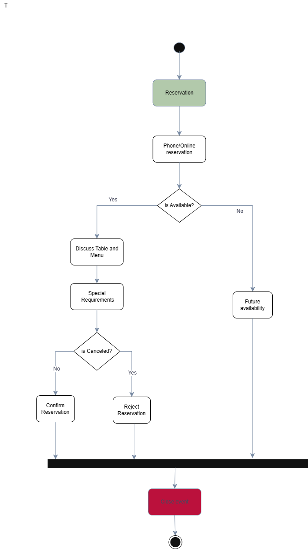Walk-in Management

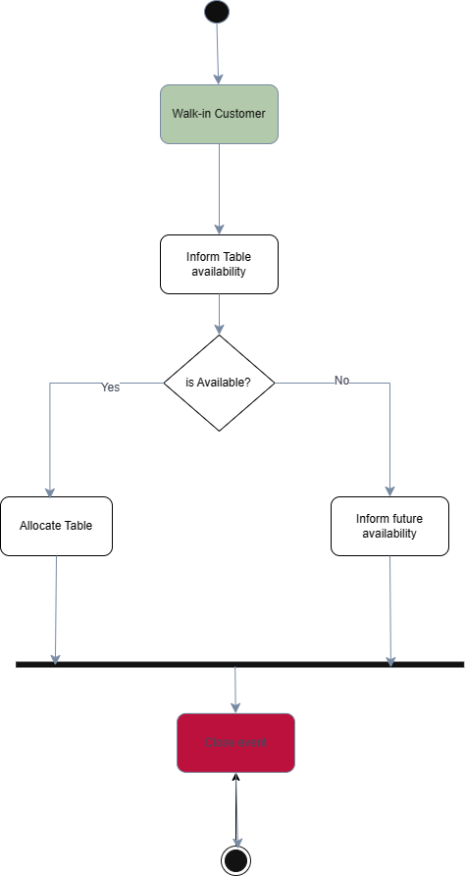

## Order Processing

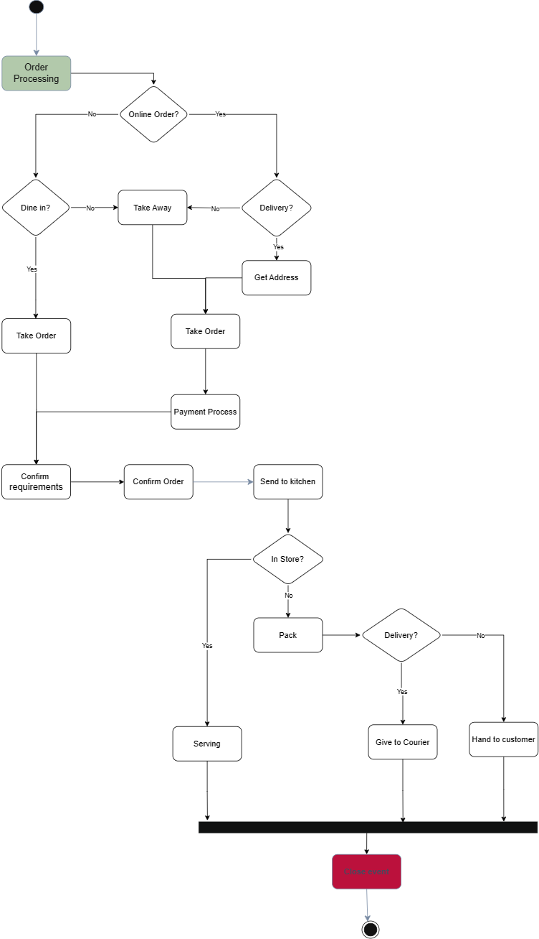

## Payment Processing

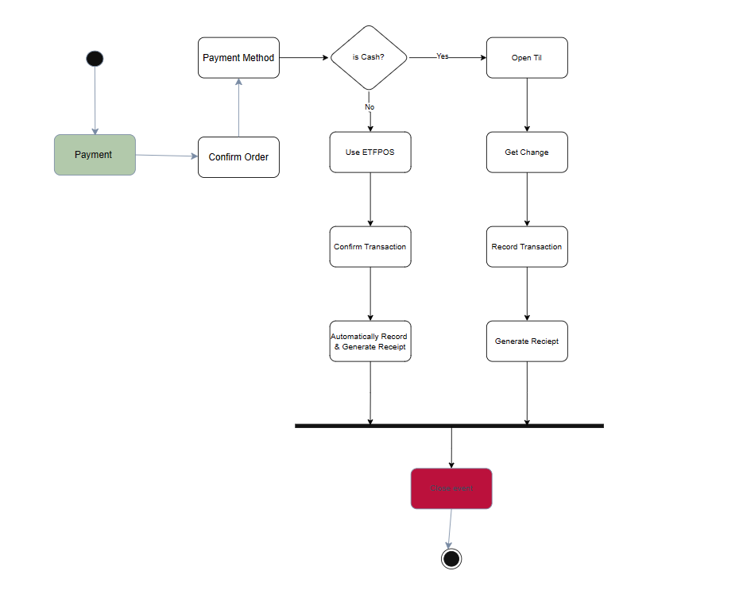

## Inventory Management

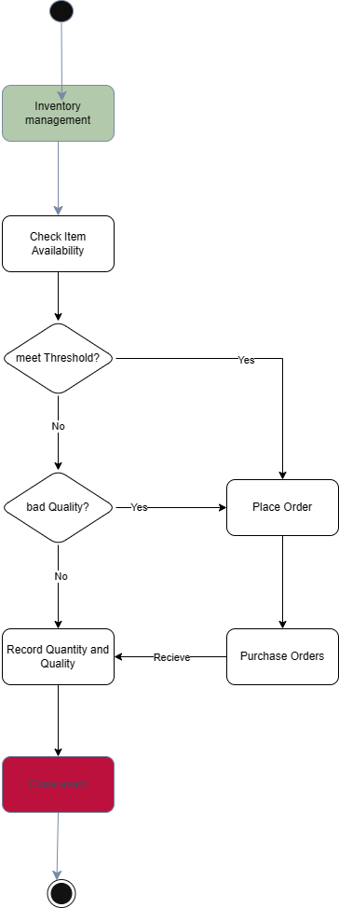

## Table Turnover Management

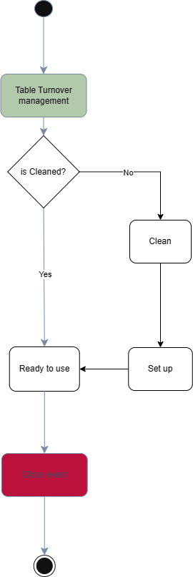

## 

## Customer Feedback Collection

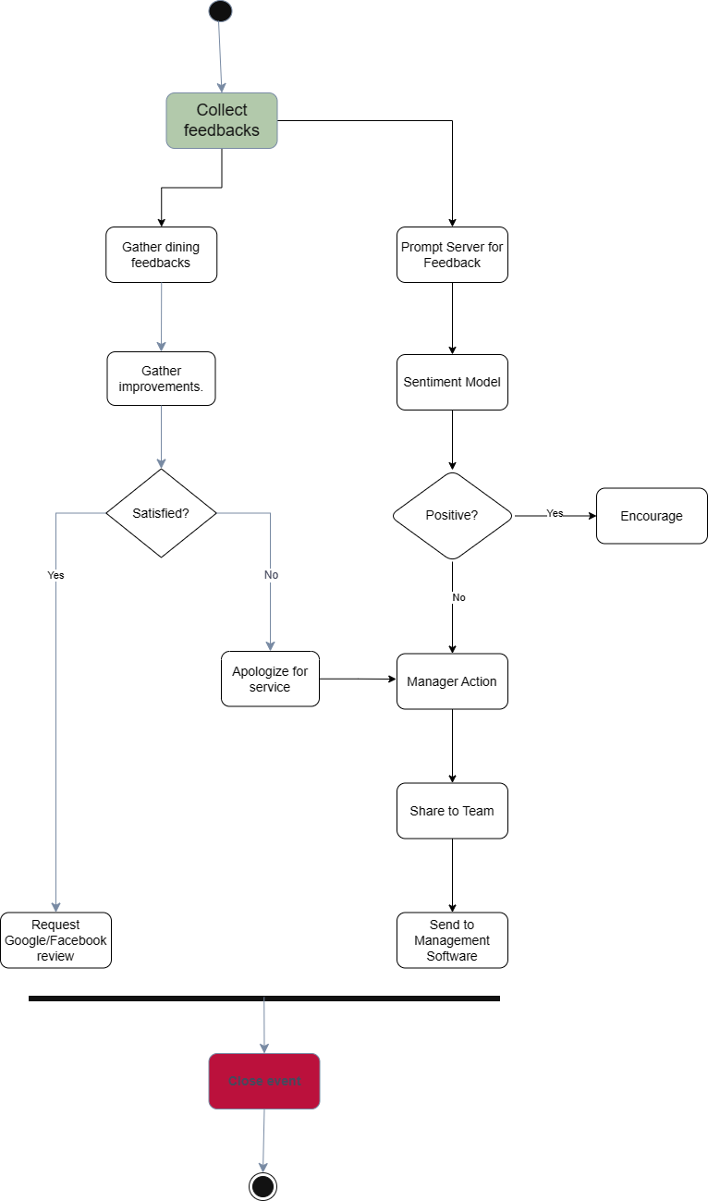

## Staff Scheduling

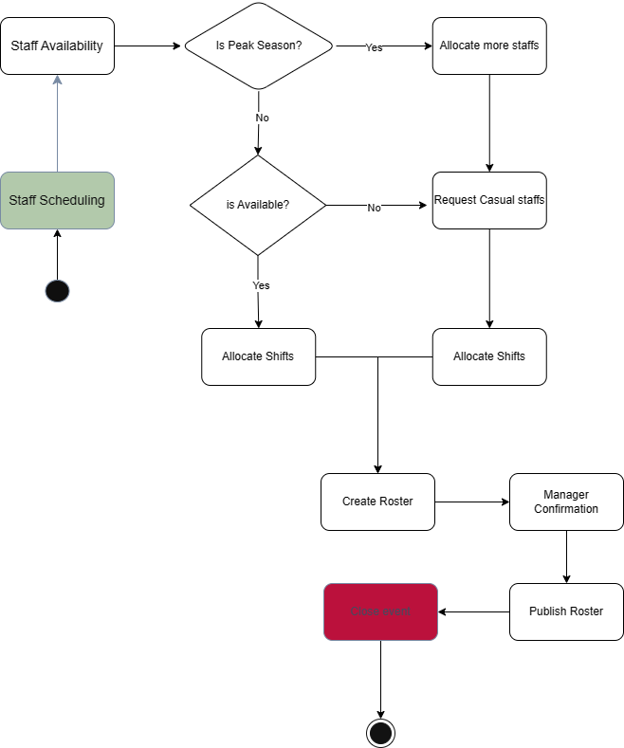

## Maintenance and Upkeep

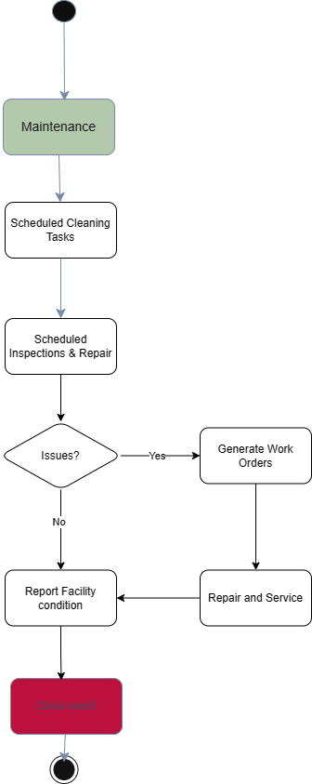

## System Maintenance and Update

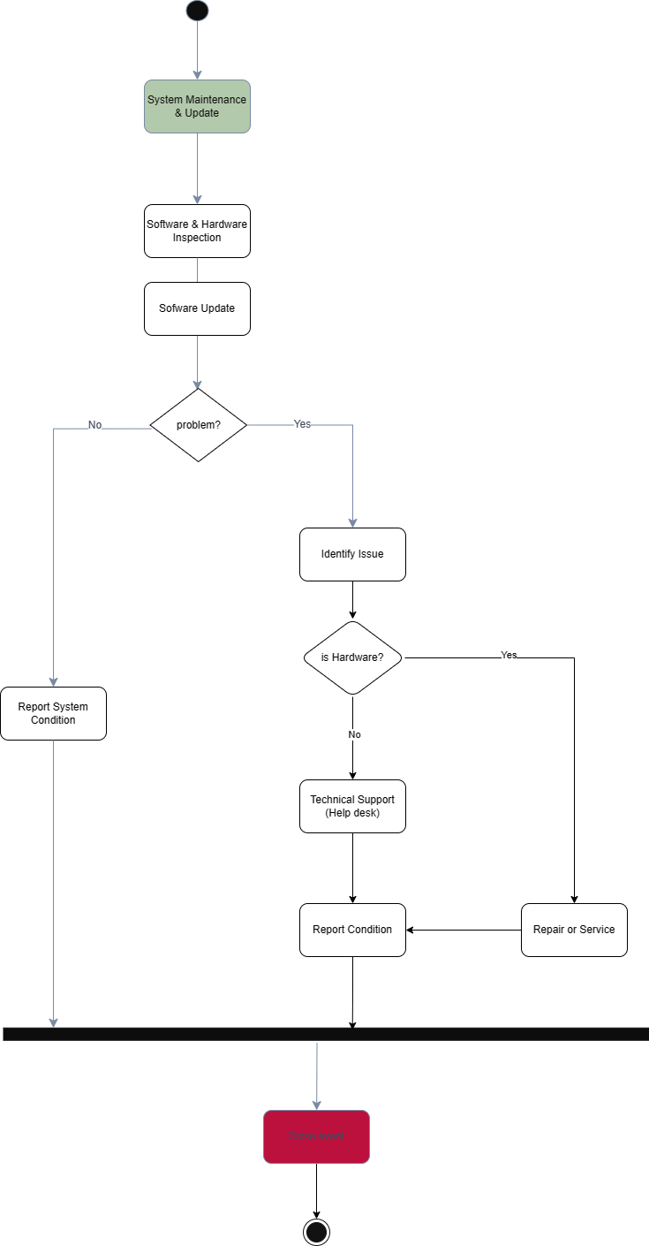

## Supplier Coordination

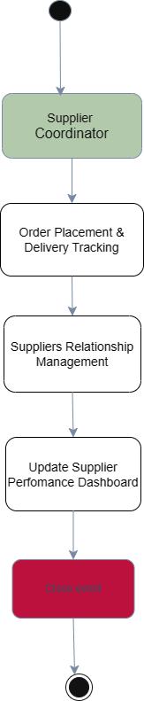

# 

# Data Model

## Domain Model

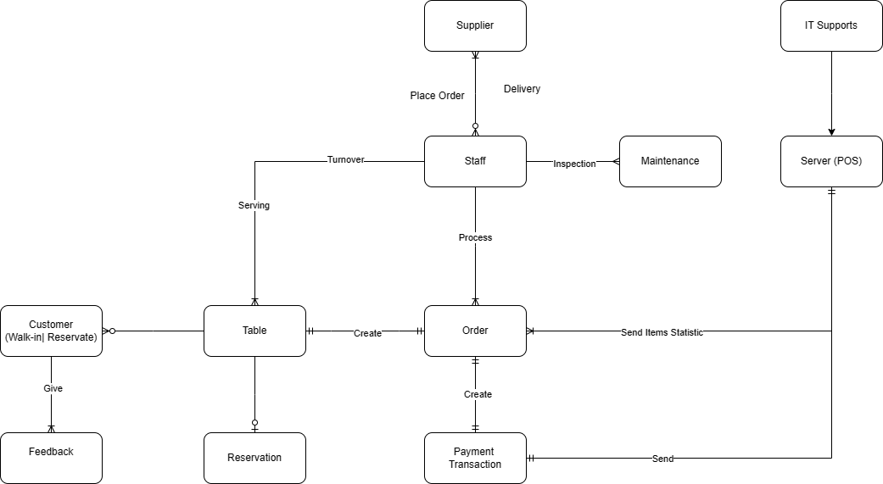

## 

## Entity descriptions

* Customer: Individuals or groups that visit the restaurant, including those with reservations and walk-ins.
* Order: The selection of menu items requested by customers, which can vary between dine-in, takeaway, and delivery options.
* Table: Physical spaces within the restaurant designated for customer dining. Includes details such as capacity and location within the restaurant.
* Reservation: A record of a table booked by a customer for a specific date and time.
* Payment Transaction: Records of financial transactions made by customers for their orders, including method of payment and amount.
* Feedback: Customer reviews and ratings regarding their dining experience, menu items, and service quality.
* Staff: Staff members of the restaurant, including servers, hosts, and kitchen staff, with details on roles and schedules.
* Maintenance: Inspection and service store equipment’s needed for business
* IT Support: Help desk responsible for problems related to software.
* Server: Database and Hosting for storing items statistic, transactions, and server for POS system

# Quality Attributes of System

## Reliability

As the restaurant will shift to relying heavily on the system, its day-to-day operations are completely dependent on ensuring the system provides uninterrupted service. The system will need to be available and running efficiently during peak hours and reduce downtime to the minimum. It has been identified that the restaurant expects its customer base to increase and a highly available system will allow for customers to reserve, order and pay for their items while freeing up staff members. On the other hand, if the system experiences downtime, it will create a bottleneck in the operations of the restaurant as they would have to fall back on their previous manual-based system. To ensure reliability, the system will have to:

* Be available 99.999% of their working hours (5 nines uptime).
* Data retrieval must maintain original data integrity every time.
* Backup data logs every 3 months.

## 

## Security

The system will store data about the restaurant staff, customers and their financial transactions. With this in mind, the system must be robust and completely secure. Sensitive information of the customer and staff members should be stored with access control mechanisms. This will be met with the following requirements:

* Apply Role-based Access Control (RBAC) to ensure users only have access to data that they require.
* Ensure authentication is enabled for all staff members in the system.
* Data stored about the customer must be compliant with The Privacy Act 1988.

## 

## Scalability

It has been identified that the owners may want to implement additional features onto the system. This means that the system must be created in a way that allows for the addition of new features seamlessly without hindering the performance of the system or its own operations. Scalability also includes accommodation of increased workload and additional staff member onboarding. The Relaxing Koala will require a system that grows alongside it to support expansions and high demand. This can be achieved by:

* Allowing for vertical scalability by adding more resources to the existing system in the future.

## 

## Portability

Accessibility through multiple platforms is essential for customer usability and for the staff. By ensuring usability through different platforms, the restaurant can open its doors for stationary people looking to reserve a table while in their house or even customers already on the go on their mobile devices. This will be done through:

* Ensuring operating system compatibility including Windows, macOS, Linux.
* Ensuring multiple device operability including computers, laptops, mobile phones, tablets.

# Other Requirements

Following the requirements stated in functional and quality requirements, these additional requirements will also be fulfilled by the system:

## Menu Management

The system will allow for managing the menu offered by the restaurant in a user-friendly interface. This will let the management staff add or delete items from the menu or temporarily provide an outage notification to a specific menu as well as change the pricing of menu items.

## Accessibility Support

Accessibility standards and guidelines will be followed in creation of the system. This will be implemented on a design level to ensure people with different disabilities are able to use the system as intended without impairment. This will be done through configuring accessibility features such as text-to-speech.

# Validation of Requirements

## Objectives of Validation of Requirements

The validation of requirements for the Restaurant Information System aims to ensure that all system requirements align with the strategic goals of The Relaxing Koala and meet the needs of all stakeholders, including management, staff, and customers. Specifically, this process seeks to ensure requirement alignment with business goals, confirm stakeholder agreement, and assess feasibility and practicality.

## Validation Process Overview

The validation process involved several key steps designed to engage stakeholders, assess the feasibility of requirements, and ensure that the proposed system meets the operational needs of The Relaxing Koala. This included stakeholder interviews, feedback sessions, and prototype testing. Requirement traceability matrices and agile user stories were utilized to track and manage the validation process.

CRUD

|  |  |  |  |  |  |
| --- | --- | --- | --- | --- | --- |
| **Entity** | **Create** | **Read** | **Update** | **Delete** | **Comments** |
| **Reservation** | ✔ | ✔ | ✔ | ✔ | Manage all aspects of reservations |
| **Order** | ✔ | ✔ | ✔ | ✔ | Handling orders including modifications |
| **Feedback** | ✔ | ✔ | ✔ | ✘ | Collect and update feedback, no delete |
| **Menu Item** | ✔ | ✔ | ✔ | ✔ | Manage menu items, including specials |
| **Inventory** | ✔ | ✔ | ✔ | ✔ | Track ingredients and supplies |
| **Employee** | ✔ | ✔ | ✔ | ✔ | Staff management including roles and shifts |

# Possible Solutions

## Standard staff-customer hybrid approach

This solution follows the process used by most restaurants, where the staff are in charge of the in-house system and the customer interacts with the staff to place their orders and confirm reservations. This approach ensures that the system is being used efficiently, as the staff will be trained on how to perform their tasks, opposed to customers trying to figure out how to operate it on their own.

The customers will still have their options of making reservations and looking at the menu from their own devices, however, to confirm their tables, they will have to interact with a staff member. As this is the industry standard, both customers and staff will have a feeling of resemblance.

The staff will be trained on operating the system and performing their tasks. The information will be stored on-site and all data will be logged for the management team to assess in the future. As walk-in customers and reserved customers are separately handled, the management team can use key datasets such as this to assess their situation.

There will be a backend office computer that will be used for administration of the system. Staff will have a front-house POS system built into a device to operate the system. This system will be integrated with EFTPOS for card payments. The POS system will include the menu for customers to order from. Once ordered and allocated a table, the system will book that table until it has been turned over and made available again. The front-house system will automatically send ordered items to the kitchen through another screen. This screen will display the orders that need to be made and will automatically be served off once it has been served by the front staff. Customers will be able to provide feedback on their orders through the server at the frontdesk. This data will be entered by the staff to help improve the standards of the restaurant.

The backend office will have the logged data about sales, which can be further analysed to see peak times and what menu items are in high demand. The restaurant will have an inventory list on this computer. Every time an item in the inventory is used for a task, it will be deducted from the inventory list for the owners to see what needs to be arranged with a supplier. The system will automatically create end of day sales reports as well as end of month reports to help the owners on their inventory stock and sales analysis.

A staff roster management service will be built into this computer for the owners to allocate staff appropriately. Staff can enter their availability times through the management team. The management team will be able to see the available staff members for each time frame and roster accordingly. This will publish the roster in advance for the staff to be notified of their scheduled shift.

## Customer self-service

The Relaxing Koala aims to significantly improve its customer experience and operational efficiency by implementing a comprehensive self-service system. This system includes self-service kiosks at the entrance and QR codes at tables for ordering and payments, linked to a digital menu. A custom mobile app supports reservations, ordering, and payments, while offering personalized recommendations and managing a loyalty program. Tabletop tablets at each table allow customers to order, customize their meals, make payments, and interact with various service features. The system supports multiple digital payment methods, emphasizing contactless transactions. Customers will benefit from real-time order tracking across all digital platforms, which would help reduce wait times and improve service accuracy. The menu displays adjust in real-time based on customer behaviour and inventory levels. Integrated feedback mechanisms and a loyalty program engage customers and encourage repeat business, while backend analytics would provide actionable insights to optimize menu offerings and promotions. The phased rollout of this system, beginning with a pilot test and accompanied by staff training and customer education, would ensure a smooth transition and widespread adoption, ultimately streamlining operations and enhancing both customer satisfaction and business profitability.

## Cloud-based solution

Considering the needs of Relaxing Koala, Abacus POS system would be the one of the best cloud-based solutions that is compatible for RK requirements. Abacus offers a wide range of extensions for Point-of-sale management as well as the ease to set up with just a single tablet but offering seamless integration and scalability with the reasonable subscription price.

Abacus offers a wide range of extensions such as Managing Reservation, process order, communicating with the kitchen, billing, creating receipts, making payments, managing the menu, and taking care online ordering, basic statistics, and reporting. This all-inclusive suite simplifies processes, enabling quick and accurate table reservations, precise order processing, and safe payment transactions. Moreover, Automated sales tracking and reporting also provide business owners with insightful data that helps them make strategic decisions in this data-driven business era.

In conclusion, the implementation of Abacus's cloud-based POS solution not only meets the Relaxing Koala restaurant’s needs but also strengthens it for future scalability and success. With its user-friendly interface, cost-effective subscription, and robust features, the solution enhances operational efficiency, improves customer experience, and enables data-driven decision-making, ultimately fostering long-term sustainability and competitiveness in the market.